Ideation Phase
Define the Problem Statements

Date | 7 November 2025
Team ID | NM2025TMID09184
Project Name | Laptop Request Catalog Item
Maximum Marks | 2 Marks

Customer Problem Statement Template:

Employees in the organization face difficulties requesting laptops through the current manual process. The workflow is time-consuming, prone to errors, and lacks dynamic form behavior to ensure correct and complete data collection.
IT support teams also struggle to track these requests, which leads to delays in approvals, confusion about requirements, and poor user satisfaction.
They need an automated Service Catalog item within ServiceNow that enables employees to quickly submit laptop requests, provides clear guidance through dynamic fields, and ensures all updates are properly tracked through update sets.
This solution will simplify request management, improve data accuracy, and enhance overall service delivery efficiency.

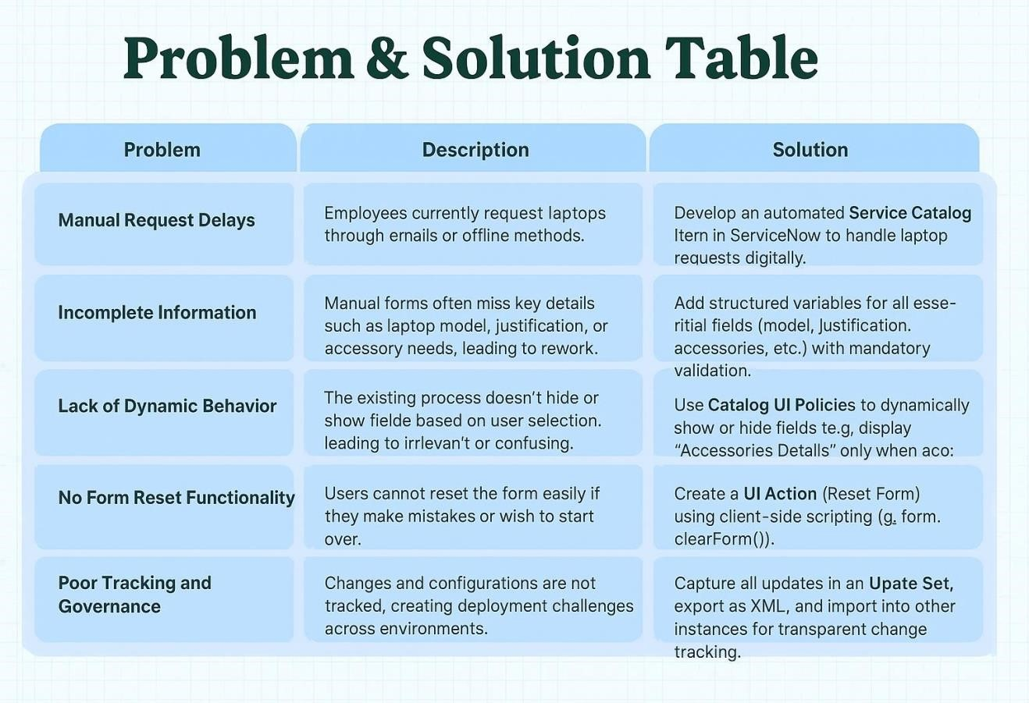
Example:
Problem | I am  (Customer) | I’m trying to | But | Because | Which makes me  feel
PS-1 | An  Employee | Request a new laptop for work | The current request process is manual and confusing | There is no automated Service Catalog item | Delayed, uncertain, and frustrated
PS-2 | An IT  Support  Staff | Manage and approve laptop requests | Requests are received inconsistently | Information is incomplete or missing in manual forms | Overwhelmed and  unable to prioritize  effectively

✓⬛Problem Statement PS 1:
As an employee, I am trying to request a laptop for my work needs, but the current manual process involves multiple emails and unclear steps.
This causes delays and confusion, as there is no structured way to capture the required details (such as model, justification, or accessories).
I need a Service Catalog item where I can easily submit my laptop request using predefined fields and dynamic options, so that the request is processed quickly and accurately without repetitive communication.
✓⬛ Problem Statement PS 2:
As an IT support staff member, I want to manage laptop requests efficiently, but manual submissions often lack important details, leading to repeated follow-ups and slow processing. There is also no centralized way to track or reset form data during submissions, which affects governance and deployment accuracy.
I need a dynamic catalog item in ServiceNow with automated UI Policies and Actions that streamline validation, enable form resets, and capture all changes in update sets — ensuring better visibility, governance, and faster service delivery.

